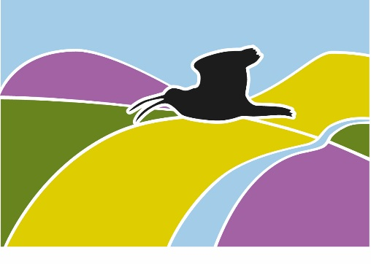
Landscape
South West Peak
Partnership
Landscape at a Crossroads

Local Farm Grant Scheme Application Form
The South West Peak Local Farm Grant Scheme allows landowners and farmers to apply for a small grant of up to £1000. Match funding is required for most types of project. The scope for grant applications is broad with many different projects considered. The funding is targeting the conservation and enhancement of the landscape, biodiversity, cultural heritage and those which are beneficial to the public, local community as well as the land managers. The project being applied for must not qualify for funding by any other existing schemes. Please see separate guidance notes for further details, example ideas for projects and and the terms and conditions of the South West Peak Local Farm Grant Scheme.
Please send your completed application form using the contact details below. If you would like help with completing your application or have any questions about the Local Farm Grant Scheme please do not hesitate to get in touch.
Post: Local Farm Grants, South West Peak team, Aldern House, Bakewell DE45 1AE
Tel: 01629 816222 / 07973 848384 (Andrew) or 01629 816386 / 07970 312531 (David)
Email: SWP@peakdistrict.gov.uk – please complete subject line as Local Farm Grant Application
Name of applicant/business:

Single Business Identifier (if applicable):

VAT Registration number (if applicable):

Address of farm or land where the project will take place or benefit.
Attach map if appropriate.

Please give details of the proposed project and what the grant will be used for.
Attach map and/or project plan and/or photographs.

What is the total cost of the project?  Exclusive of VAT if registered, include VAT if you can’t claim it back. | What is the total grant amount being applied for? (note that we can only pay up to £1000 or 75% of total costs, whichever is less) Exclusive of VAT if registered, include VAT if you can’t claim it back.
Please give a breakdown of the costs for the project including the sources of your information (attach 3 quotes).

How will the project benefit the wider community and protect or enhance the landscape/biodiversity/cultural heritage of the holding and the wider area?
Max 200 words.

Additional notes that may help your application.

I declare that all the information in this form is correct; I have read and agree to the eligibility criteria, terms and conditions stated in the separate guidance notes and that I wish to apply for a South West Peak Local Farm Grant.

Signed ………………………………………………………………………………………………… Date: ……………………………………………………….

“By working together in the South West Peak, we will shape a better future for our communities, landscape, wildlife and heritage where trust and understanding thrive.”

